Smart Clock
Manual
V1.2.2

Video Tutorial：
https://youtu.be/HEUGHo3RDcY

Step1.
Connect the data cable, turn on the clock.
Turn on your phone -> Setting -> WLAN or Wi-Fi.
Connect to this: Smart Weather Clock.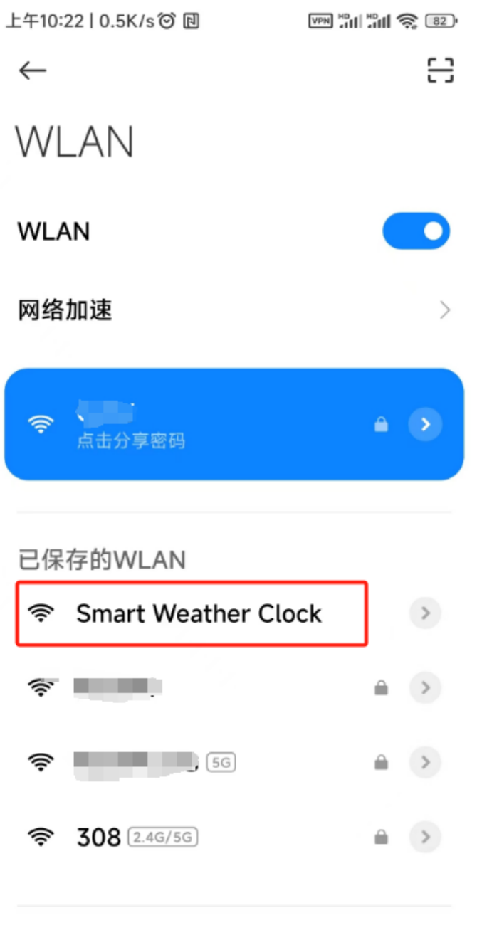

Tips:If the phone hint that this network has no Internet, it may not be safe. Please trust this network and keep linking.

The setting page will pop up automatically.
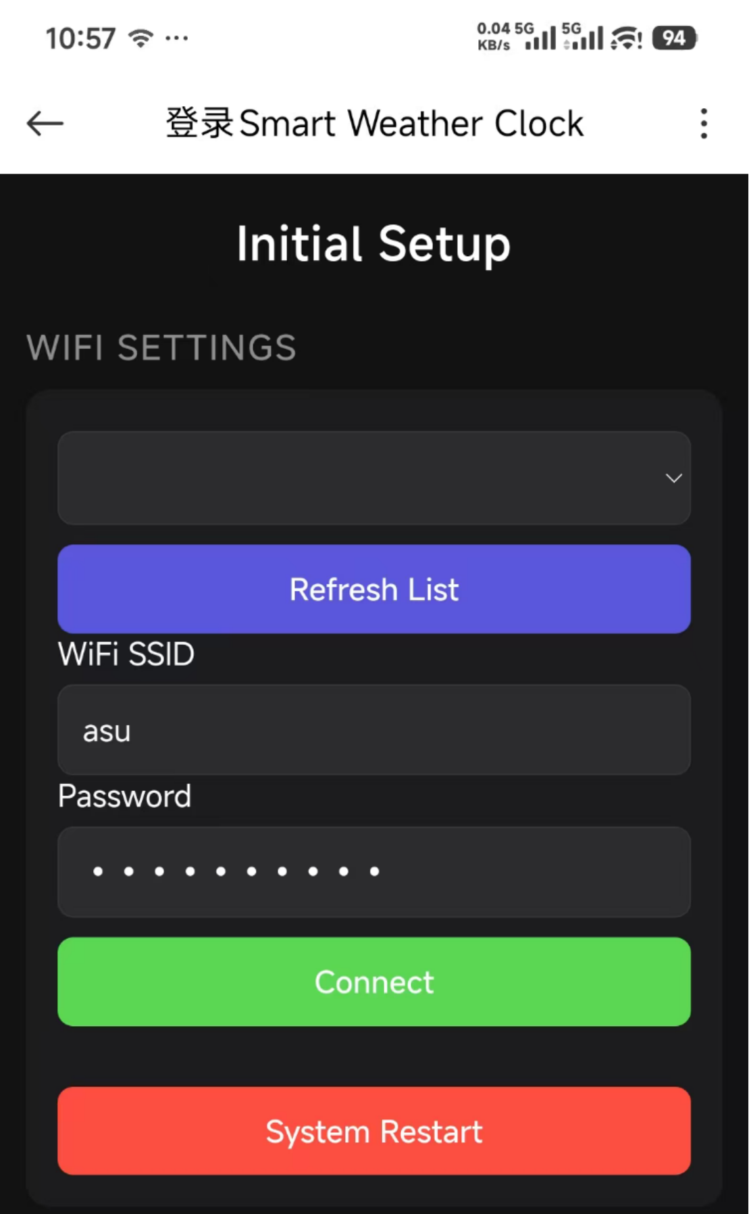
Tips:If the setup page pops up automatically, skip these two pages and go directly to
step 2.
If the settings page does not pop up,
keep your phone connected to the
"Smart Weather Clock" WiFi and turn off mobile cellular data for your phone.
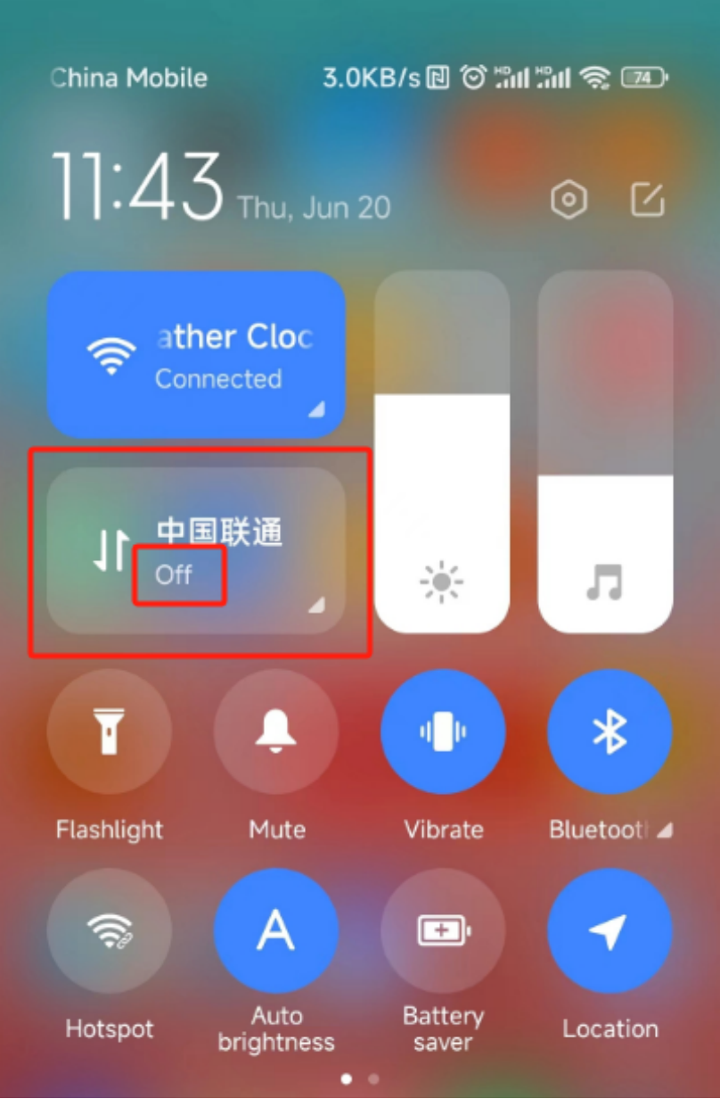
Then enter 192.168.4.1 in your mobile browser to open the settings page.）
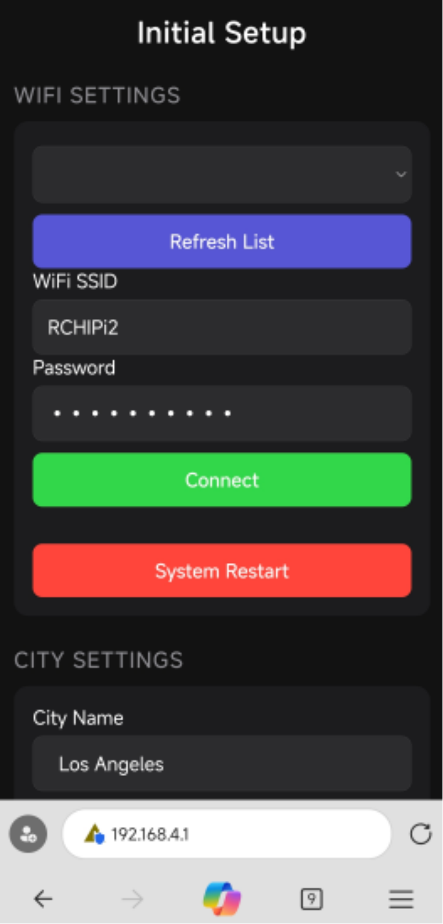

Step2.
After the page opens,click the drop-down list under WiFi Settings, select your WiFi name, and enter the password, and click Connect.
Then the clock will automatically restart.
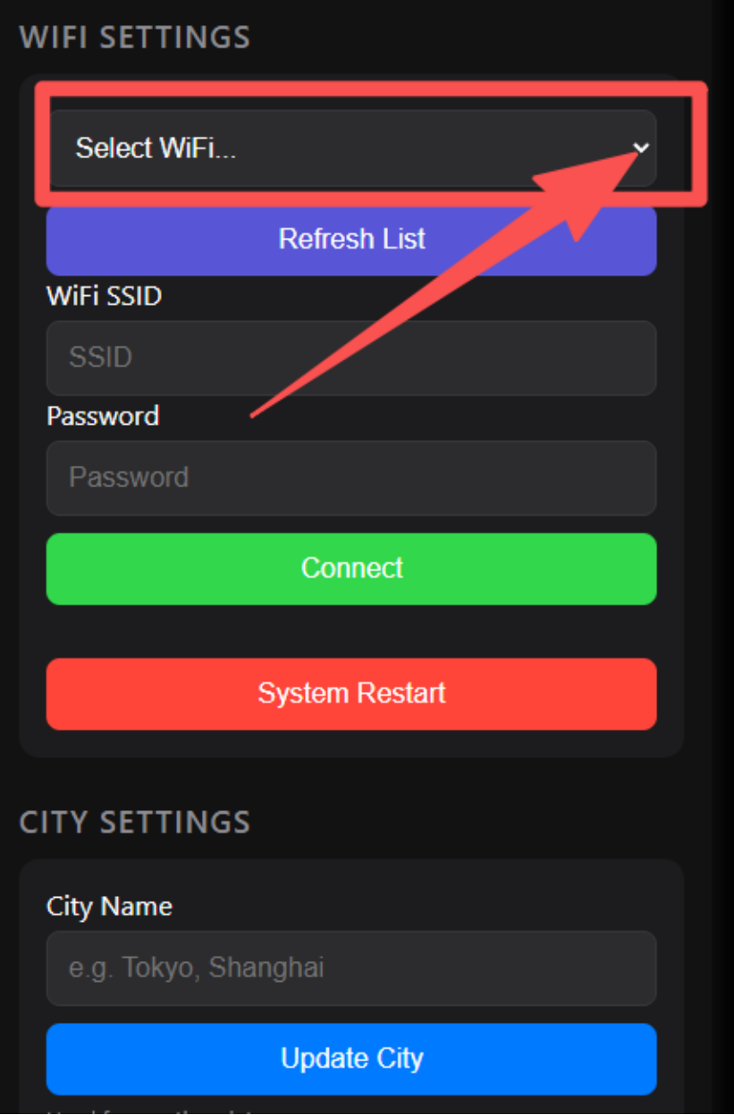

Tips:If the drop-down list does not have the name of your home Wi-Fi network, go back and click the green refresh button, then click the drop-down list again.
2. When the clock is turned on, a yellow IP address will be displayed, or after it is turned on, an IP address will be displayed in rotation in the upper left corner such as:
192.168.*.*
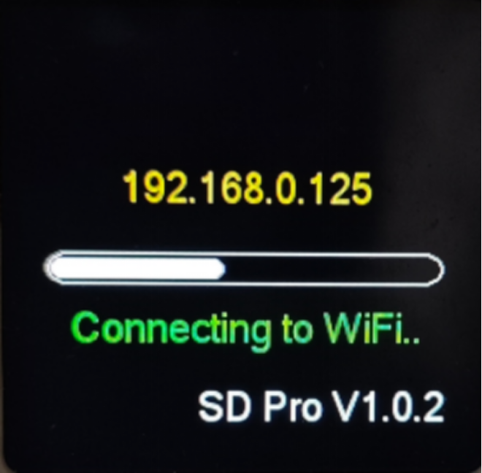
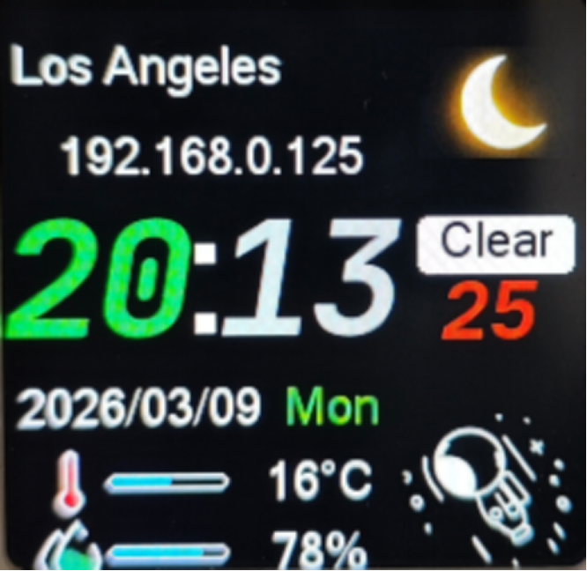

Step3.

Open your mobile browser and enter this IP address, which will open a more comprehensive settings page.
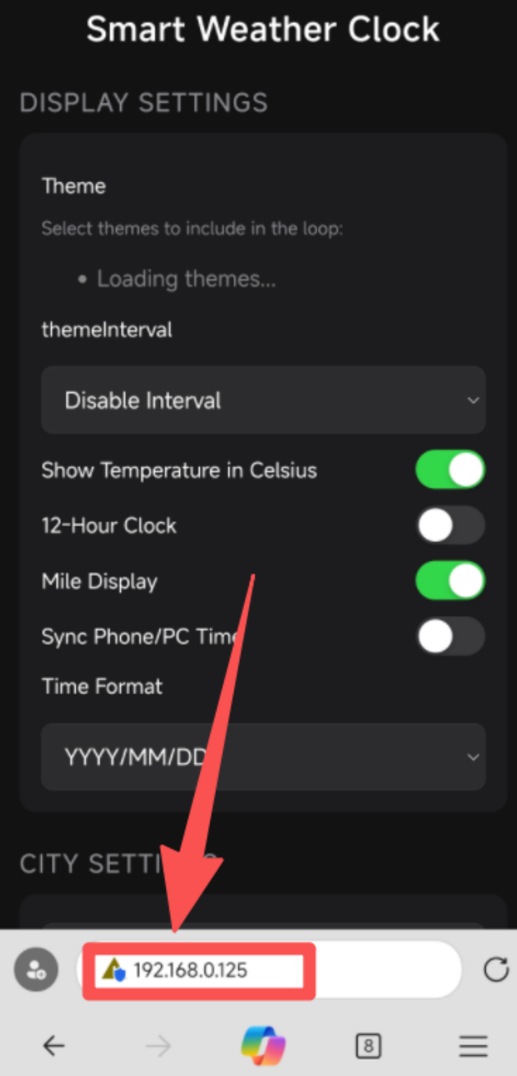

Here, you can set your city name.The input format is similar to:

London or New York
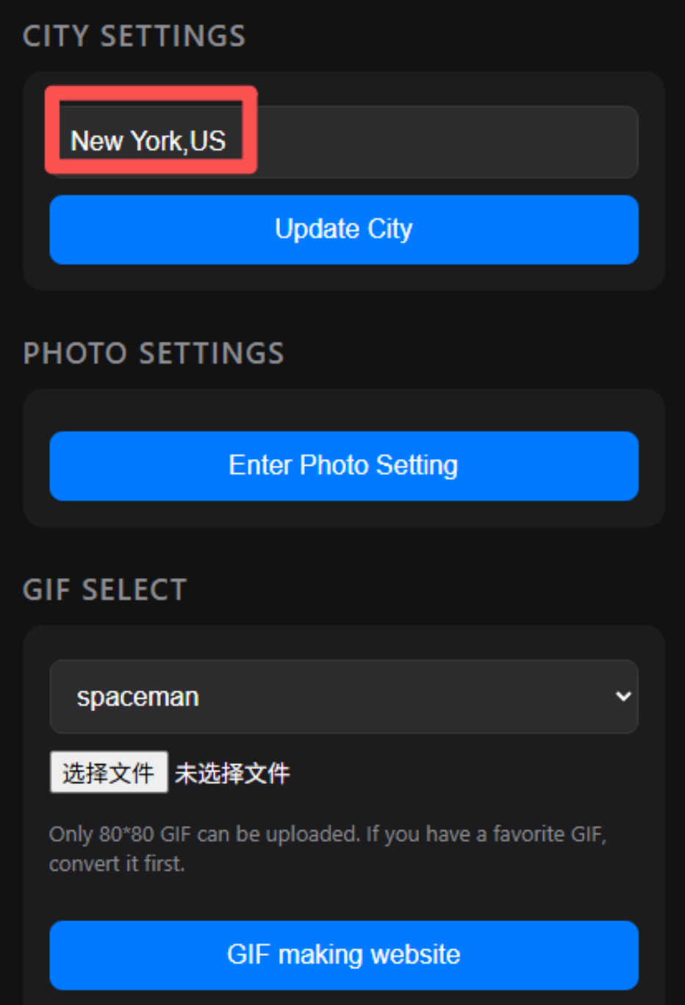

Enter the English city name first, followed by a comma "," and then the country abbreviation.

If the clock does not display your current city after entering the city name, please check here to see if your city is correct:
openweathermap.org

Step4.Set other functions.

Step5. Enjoy!

For video tutorials and other function,
please visit this link：www.bit.ly/smwec
Technical Support: ychj90@gmail.com

Q&A:
Q1:
Why can't I connect to the router?
It keeps getting stuck on the initial page.
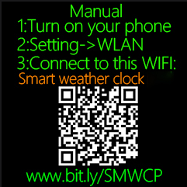
A1:
Connection failure is usually caused by one of the following:
1. The clock is too far from the router.
2. The router is broadcasting a 5GHz Wi-Fi signal instead of a 2.4GHz signal (this device only supports 2.4GHz networks).
3. The router has a firewall enabled.
4. The 2.4GHz Wi-Fi encryption method is incompatible with the clock.
Please try creating a hotspot using another mobile phone and connecting the clock to it to test if the connection works.
If the connection is successful, try moving the clock closer to the router, disabling the firewall, and changing the 2.4GHz Wi-Fi encryption method to AES, then try again.

Q2:
I can connect to my home router network, but the city name cannot be displayed. There is no weather information.The year is 1970.
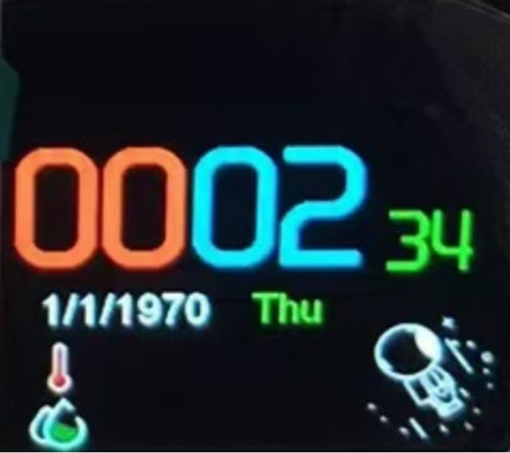
A2:
First, check the router to see if it is distributing Internet to the clock.If you are unsure, find an Android phone and turn on the hotspot, then connect the clock to the hotspot. If it works properly, then there is nothing wrong with the clock settings.

Some campus networks, shopping malls, supermarkets, hotels, KFC, McDonald's and other public places' networks (which require secondary verification) cannot distribute Internet to clocks.

Q3:
Why is my city name showing as “null” and other weather information is also wrong.
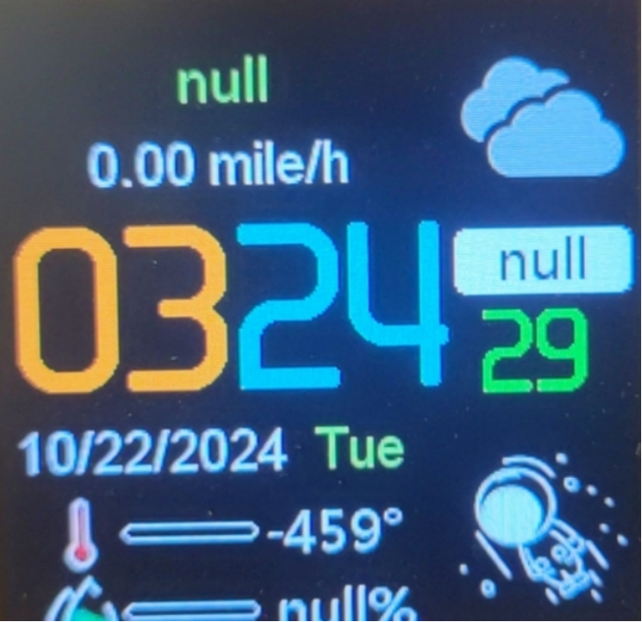
A3:
This is because the OpenWeatherMap Key is set incorrectly.
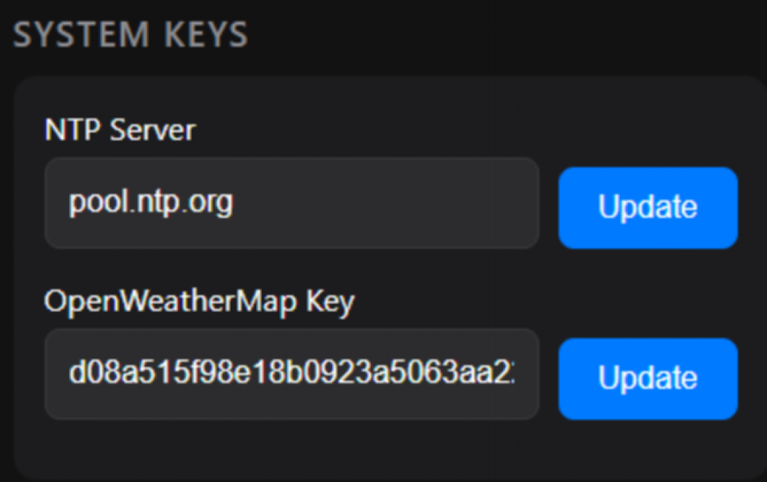
OpenWeatherMap Key：
7b8575e0c7d3e56ec6f90dcf4e8b28a8
a12424d45612943f07c016e68c3d97d6

If it doesn't work, you can go to this website to register the corresponding key：
openweathermap.org

Q4:
Why is there a city displayed, but the time is 1970?
A4:
NTP server settings error.
The correct one should be:

pool.ntp.org

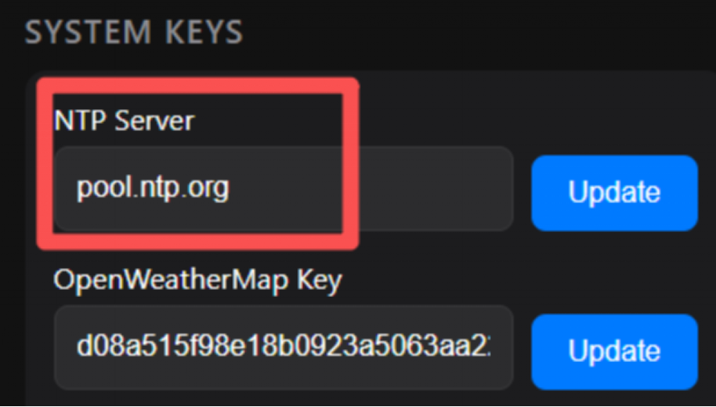
If this server is not working, please search for NTP servers near your city on Google. Then enter here and update.
If that still doesn't work, try turning on this switch.
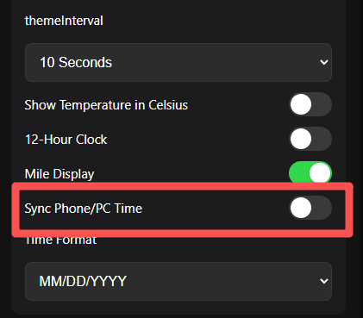

Q4:
Clock reminder needs to be activated.

A4:
Use the browser to open the corresponding IP address.
Copy the Mac code on the webpage and send it to the after-sales email address.
ychj90@gmail.com

The staff will see it and send you the corresponding license. You can paste it and use it normally.

